**🏠 HOME｜首页**

**Hero Section（第一屏）**

**🇺🇸 English**

**Reliable Functional Ingredients, Built for Scale**  
U.S.-based sourcing and distribution for dietary supplement, functional food, and food & beverage companies.

Global supply partnerships, documented quality, and end-to-end execution — so you can source with confidence and focus on growth.

**CTA**

* Request a Quote
* Ask for Specs & COA

**🇨🇳 中文**

**为规模化而构建的可靠功能性原料供应**  
面向膳食补充剂、功能食品及食品饮料企业的美国本土原料采购与分销平台。

通过全球协作供应体系、可验证的质量文件以及全链路执行能力，助力客户安心采购、专注业务增长。

🖼️ 首页主视觉配图

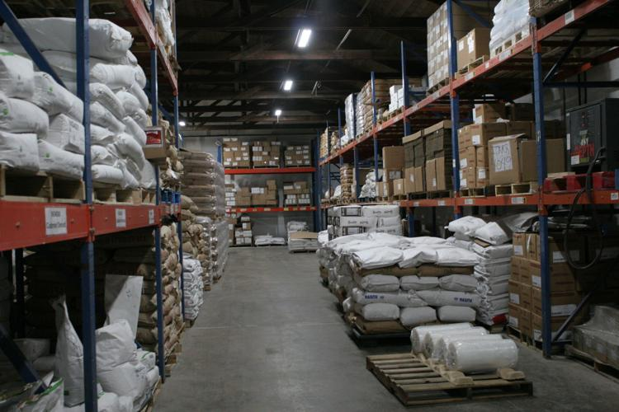

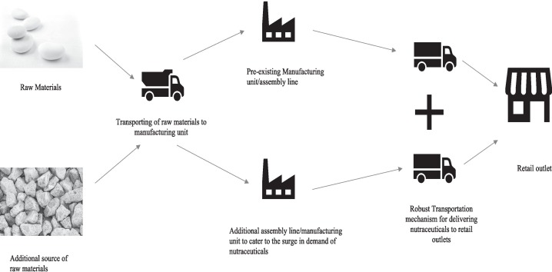

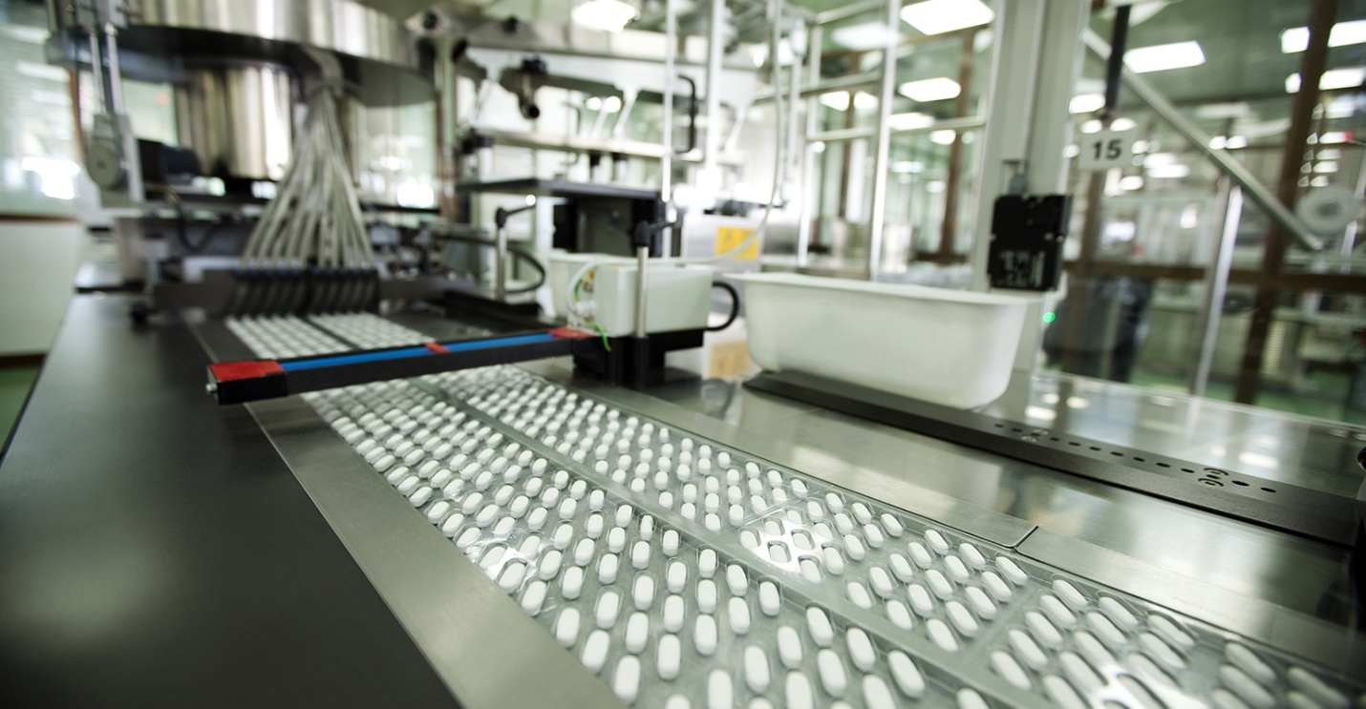

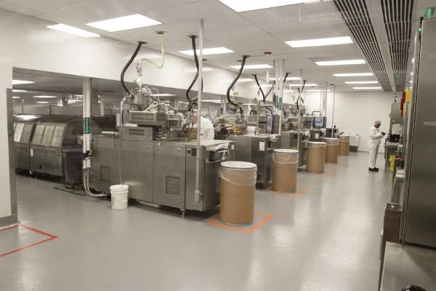

**Pain Points｜我们理解客户的现实挑战**

**🇺🇸**

Sourcing ingredients in today’s global trade environment often means:

* Inconsistent quality and supply uncertainty
* Long lead times and customs complexity
* Fragmented logistics responsibilities
* Excessive communication and coordination costs

**🇨🇳**

在当前复杂多变的国际贸易环境下，原料采购往往面临：

* 质量与供应稳定性不足
* 交期长、清关流程复杂
* 物流责任分散、衔接困难
* 沟通与协调成本过高

**Our Solution｜Omni 的整体解决方式**

**🇺🇸**

Omni Ingredients simplifies sourcing by combining:

* U.S.-based operations and warehousing
* Long-term partnerships with qualified manufacturers
* **End-to-end international logistics and trade execution**
* Documented, traceable quality systems
* Self-service tools that improve transparency

From international ocean and air freight to customs clearance and final delivery, we manage the full supply chain — allowing customers to focus on products, brands, and commercialization.

**🇨🇳**

Omni Ingredients 通过以下方式简化原料采购：

* 美国本地运营与仓储
* 与优质原料工厂的长期合作
* **覆盖海运、空运、清关报关及门到门运输的全链路物流执行**
* 完整、可追溯的质量体系
* 提升透明度、降低沟通成本的自助化工具

从国际运输到清关再到最终交付，我们统筹整个供应链流程，让客户无需为物流问题分心。

🖼️ 解决方案配图

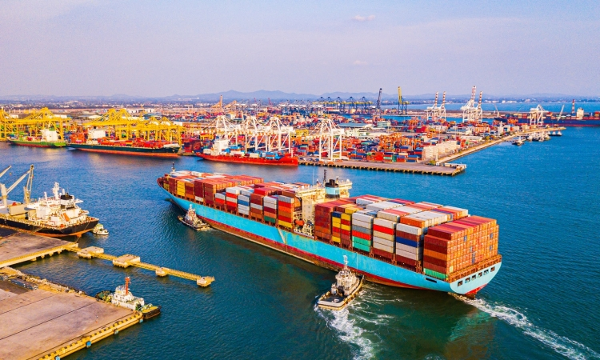

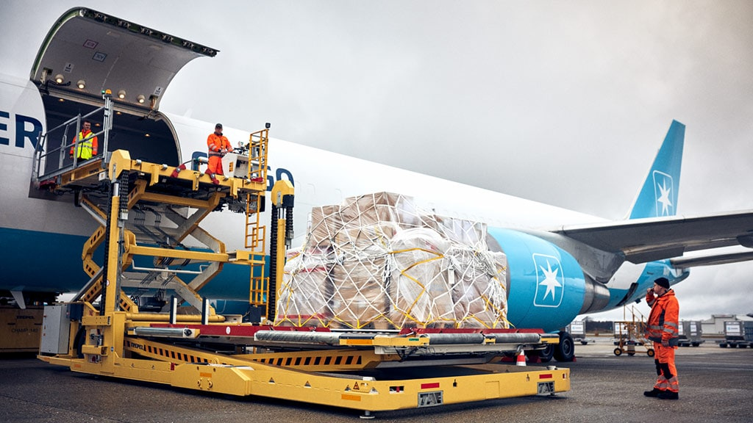

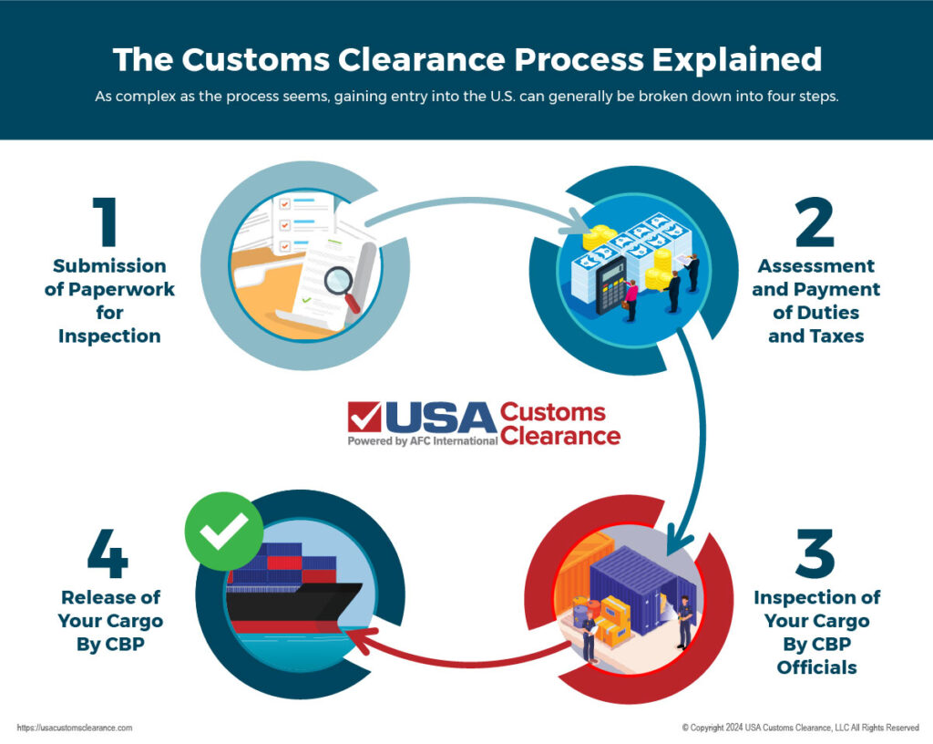

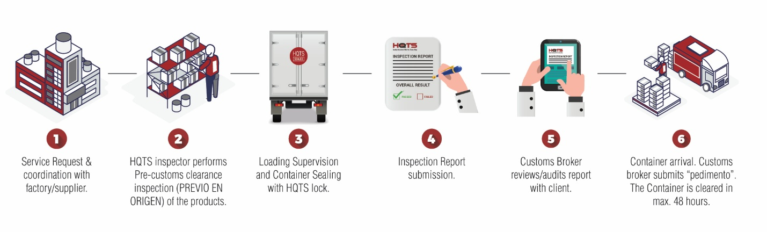

**🏢 ABOUT US｜关于我们**

**🇺🇸 English**

**Omni Ingredients is a U.S.-based functional ingredient sourcing and distribution platform**, serving dietary supplement, functional food, and food & beverage companies.

Beyond distribution, we are backed by a strong R&D-driven parent group. Through close technical collaboration with selected upstream manufacturers, we support process optimization, production consistency, and scalable long-term supply.

In addition, we engage in strategic, long-term partnerships with high-quality manufacturers to align production capability, quality standards, and market needs.

Our role is clear:  
to reduce supply risk and deliver ingredients customers can rely on — from origin to final delivery.

**🇨🇳 中文**

**Omni Ingredients 是一家美国本土运营的功能性原料采购与分销平台**，服务于膳食补充剂、功能食品及食品饮料企业。

在分销业务之外，我们依托母公司强大的研发与技术能力，与精选的上游原料工厂开展技术协作，持续优化生产工艺、提升稳定性，并构建可规模化的长期供应体系。

同时，我们与部分优质原料工厂建立战略性、长期合作关系，使生产能力、质量标准与市场需求保持高度匹配。

我们的职责非常明确：  
从原产地到最终交付，为客户降低供应风险，提供值得信赖的原料解决方案。

🖼️ About 页面配图



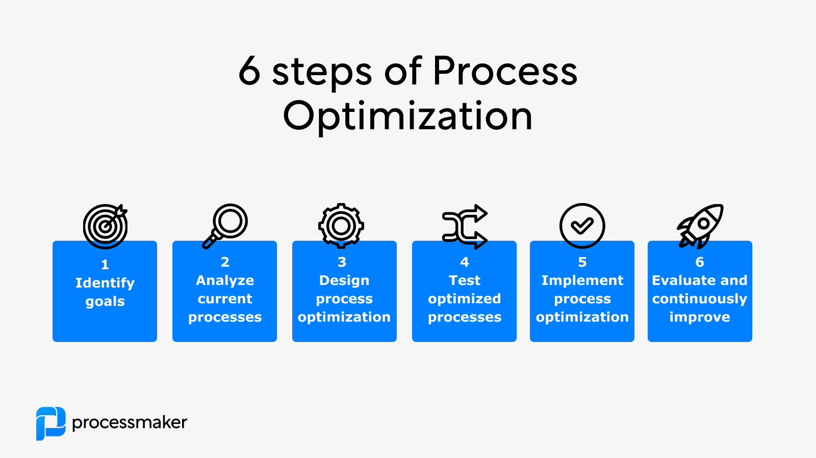





**⭐ WHY CHOOSE US｜为什么选择 Omni**

**🇺🇸**

**Built for reliability in complex markets**

* U.S.-based warehousing and fulfillment
* Manufacturer partnerships supported by technical collaboration
* Focus on process consistency, not just batch testing
* End-to-end logistics and customs coordination
* Systems designed to scale with customer growth

**🇨🇳**

**为复杂市场环境下的稳定供应而构建**

* 美国本地仓储与交付能力
* 以技术协作为基础的工厂合作关系
* 不仅关注检测结果，更重视工艺稳定性
* 全链路物流与清关执行能力
* 面向规模化增长设计的系统化运营

🖼️ Why Choose Us 配图

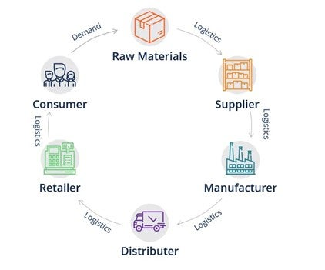

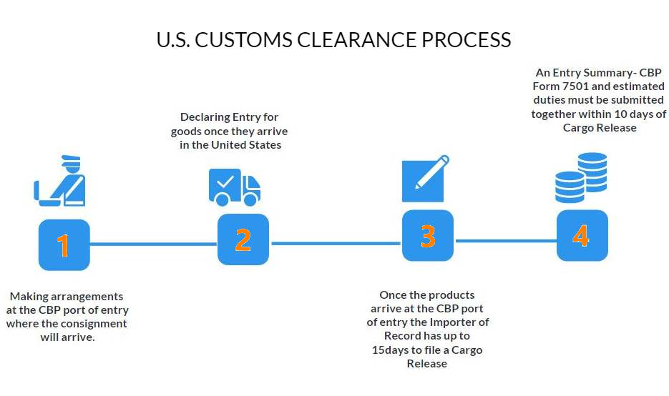



**📦 PRODUCTS & SOLUTIONS｜产品与解决方案**

**Functional & Nutritional Ingredients**

**🇺🇸 English**

Our ingredient portfolio supports a wide range of health and performance applications, including:

* **Antioxidant & Cellular Health**
* **Energy & Metabolic Support**
* **Immune & Liver Health**
* **Beauty-from-Within Formulations**
* **Sports Performance & Recovery**
* **Mood, Stress & Cognitive Support**

We work with manufacturers we understand not only commercially, but technically — allowing us to offer consistent specifications, predictable supply, and reliable documentation for U.S. customers.

**🇨🇳 中文**

我们的原料组合覆盖多种健康与功能应用场景，包括：

* 抗氧化与细胞健康
* 能量与代谢支持
* 免疫与护肝健康
* 内服美容解决方案
* 运动表现与恢复
* 情绪管理、抗压力与认知支持

我们合作的原料工厂在商业与技术层面均经过深入了解，从而确保规格一致、供应可预期，并为美国客户提供完整可靠的文件体系。

🖼️ 产品应用配图

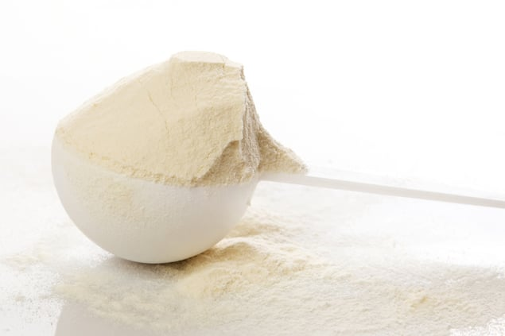

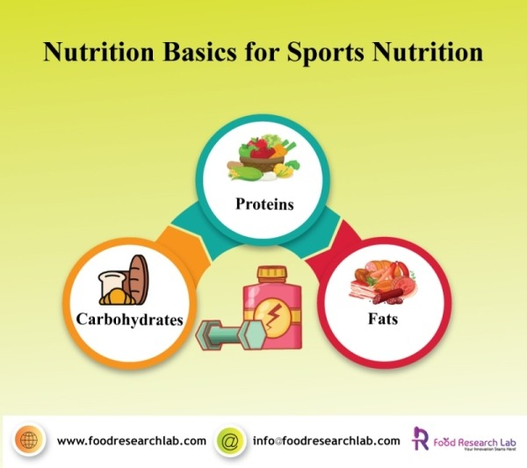

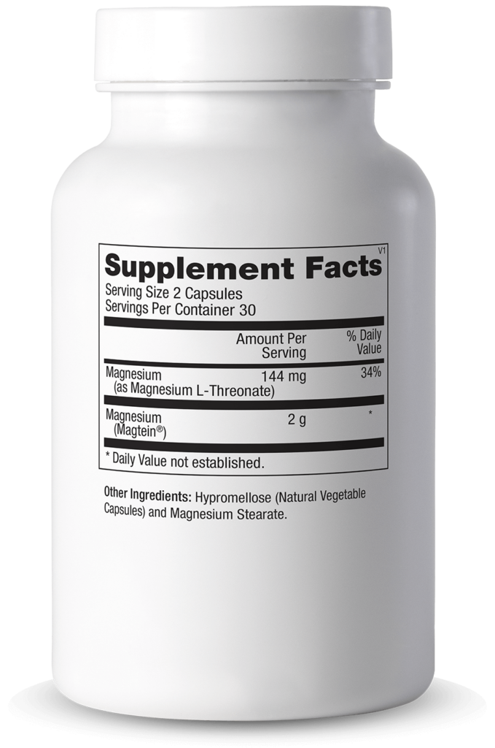

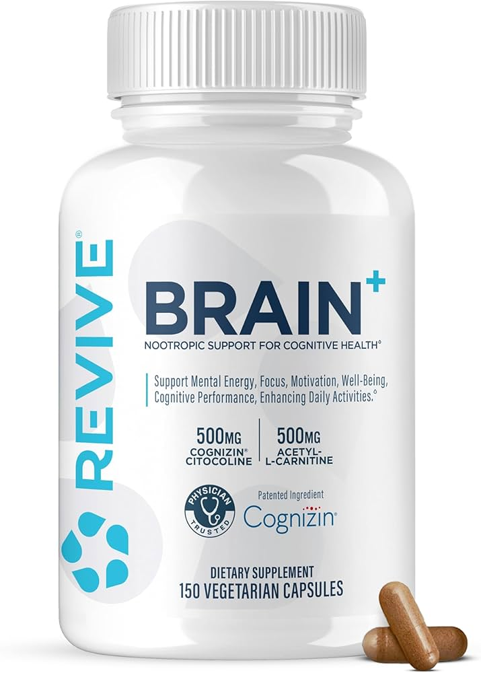

**Premix & Custom Blend Solutions｜预混与定制方案**

**🇺🇸**

In addition to single-ingredient sourcing, Omni Ingredients offers **pre-formulated and customized premix solutions** designed to simplify formulation and improve manufacturing efficiency.

Our premix solutions include:

* **Multi-Vitamin & Mineral Premixes**
* **Green & Plant-Based Nutrition Premixes**
* **Sweetener & Flavor-Enhancing Premixes** for sugar reduction and taste optimization

These solutions help customers reduce formulation complexity, improve batch consistency, and shorten development timelines.

**🇨🇳**

除单一原料外，Omni Ingredients 同时提供**预配方与定制化原料预混解决方案**，帮助客户简化配方设计并提升生产效率。

预混方案包括：

* 多种维生素与矿物质预混
* 绿色与植物营养预混
* 代糖与风味提升预混（用于低糖、减糖体系）

这些方案可帮助客户降低配方复杂度、提高批次稳定性并缩短产品开发周期。

🖼️ 预混方案配图

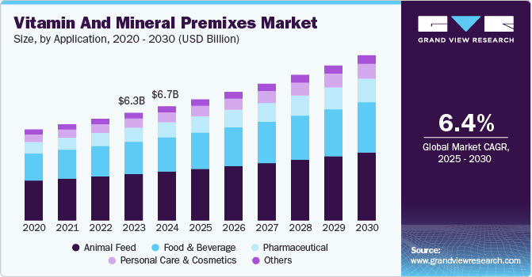

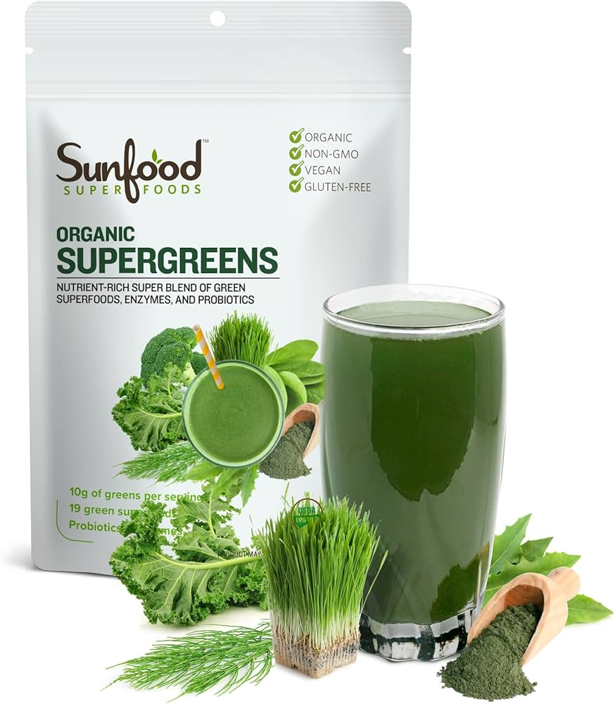

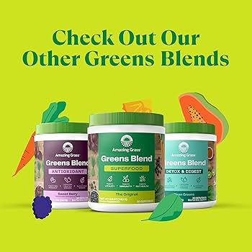

**🧪 QUALITY & COMPLIANCE｜质量与合规**

**🇺🇸**

Quality is not a feature — it is our baseline.

Our framework includes:

* Supplier qualification and ongoing review
* Batch-level COA and traceability
* Third-party testing when required
* Clear understanding of U.S. dietary supplement and food regulations

**🇨🇳**

质量不是附加项，而是我们的基本要求。

我们的质量体系包括：

* 供应商审核与持续评估
* 批次级 COA 与可追溯体系
* 必要时的第三方检测
* 对美国膳食补充剂及食品法规的清晰理解

🖼️ 质量合规配图

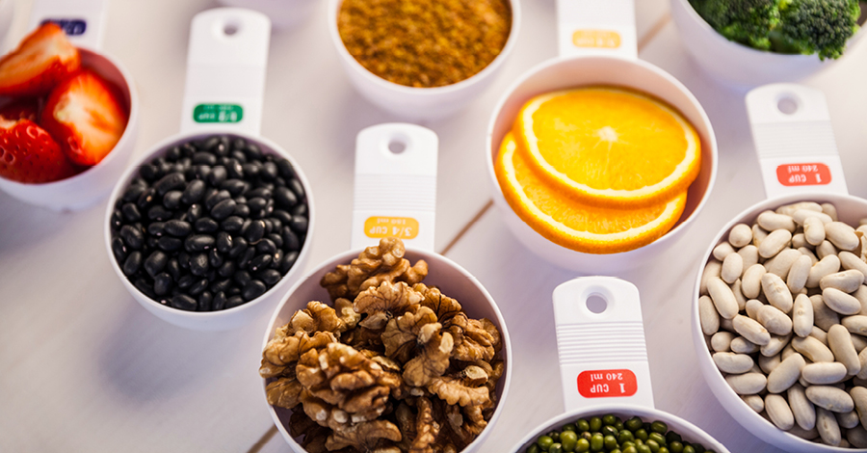

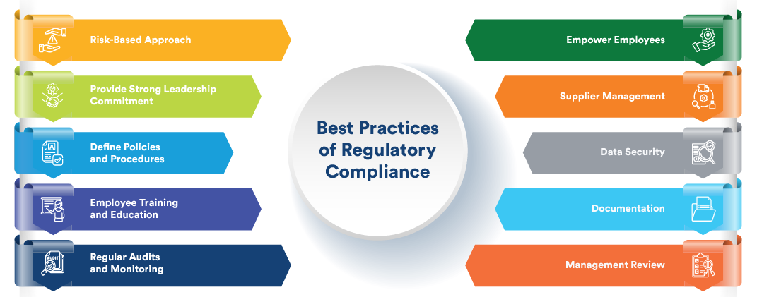

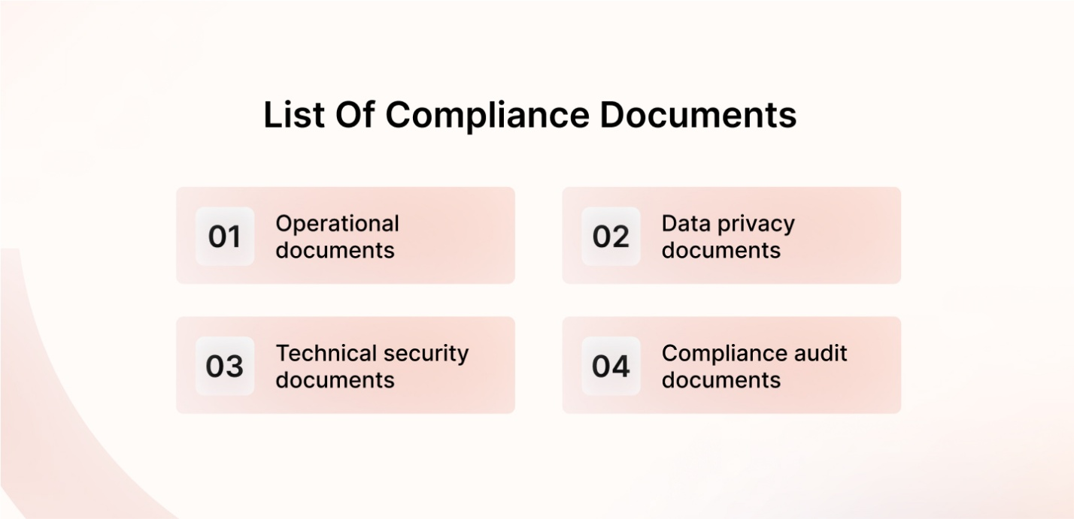

**⚙️ SERVICES & PLATFORM｜服务与客户平台**

**Self-Service & End-to-End Execution**

**🇺🇸**

Omni Ingredients is building a customer-facing service platform designed to reduce friction and improve supply chain visibility.

Customers can:

* Request small-quantity samples with minimal effort
* Access specifications, COAs, and technical documents on demand
* Track order fulfillment and shipment status in real time

Combined with our end-to-end logistics execution — from international shipping and customs clearance to final delivery — this approach removes operational burden and uncertainty.

**🇨🇳**

Omni Ingredients 正在打造一套面向客户的自助式服务平台，用于提升效率与供应链透明度。

客户可通过平台：

* 低成本、自主申请小批量样品
* 即时获取规格、COA 与技术文件
* 实时查看订单与发货进度

结合我们覆盖国际运输、清关及门到门交付的全链路执行能力，有效消除操作负担与不确定性。

🖼️ 平台与系统配图

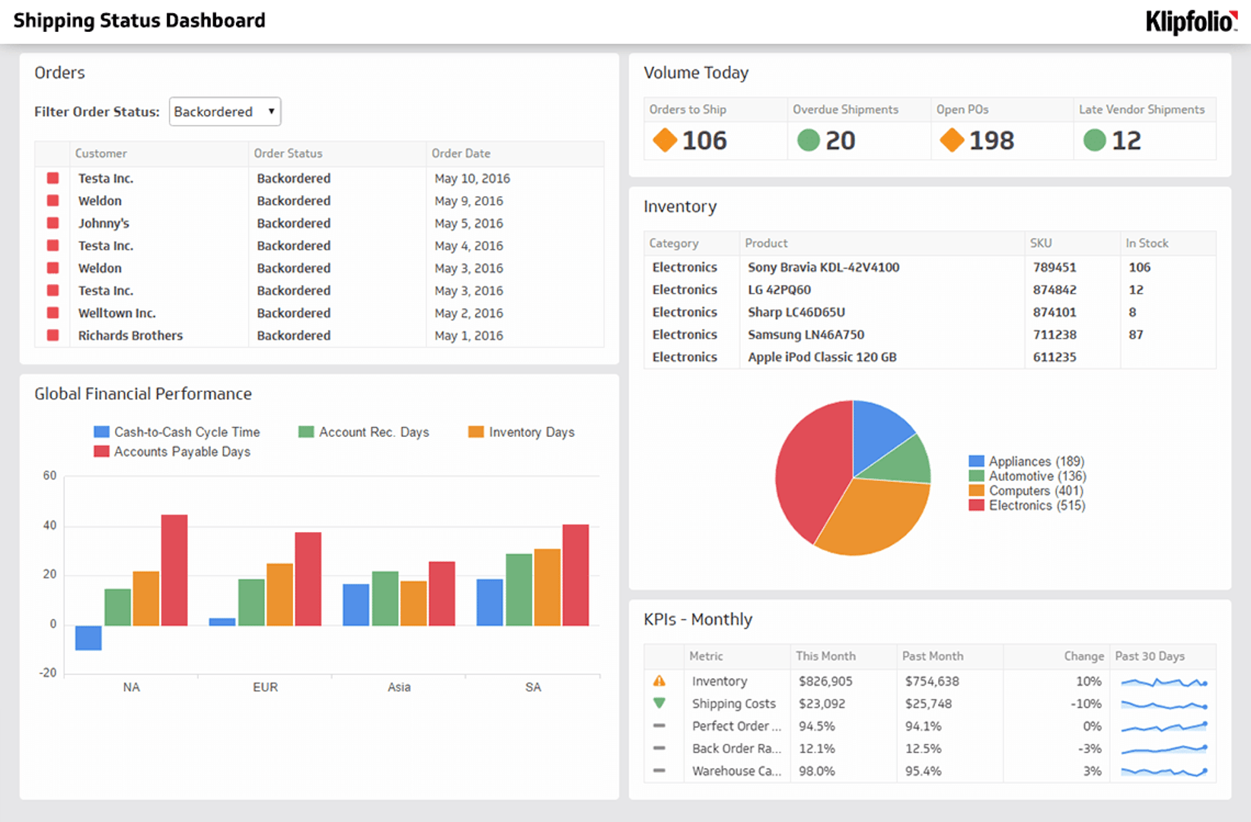

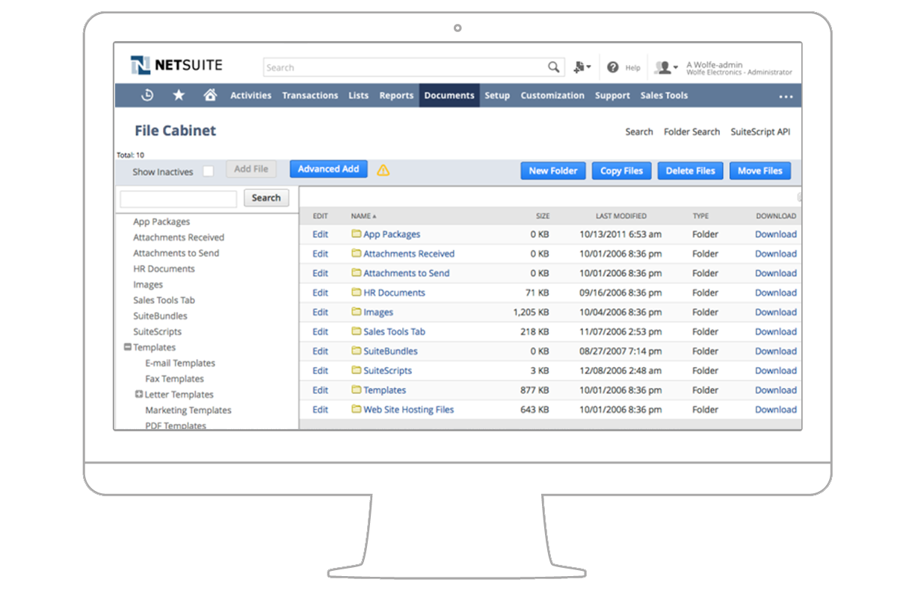

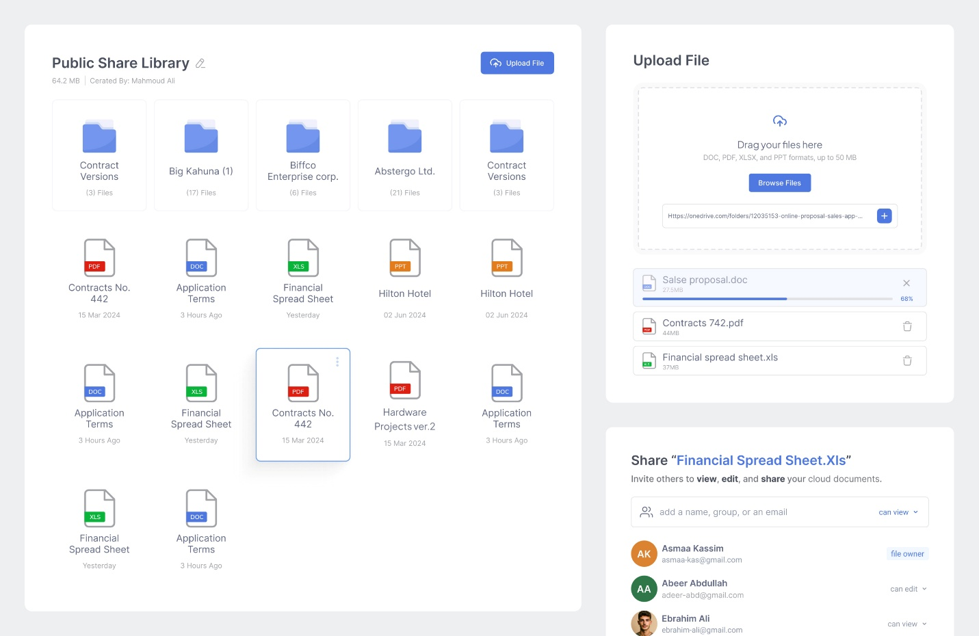

**👥 WHO WE SERVE｜服务对象**

**🇺🇸**

We work with:

* Dietary supplement brands
* Functional food manufacturers
* Food & beverage companies
* Formulation and R&D teams
* Distributors and contract manufacturers

**🇨🇳**

我们的客户包括：

* 膳食补充剂品牌
* 功能食品制造商
* 食品与饮料企业
* 配方与研发团队
* 经销商与代工厂

**✉️ CONTACT US｜联系我们**

**🇺🇸**

Let’s discuss your ingredient, premix, and supply chain needs.

Contact us to:

* Request pricing and availability
* Access specifications and documentation
* Discuss applications, premix solutions, and logistics planning

**🇨🇳**

欢迎与我们沟通您的原料、预混及供应链需求。

可联系我们：

* 获取报价与库存信息
* 索取规格与文件
* 探讨应用场景、预混方案与物流规划

🖼️ 联系页配图

